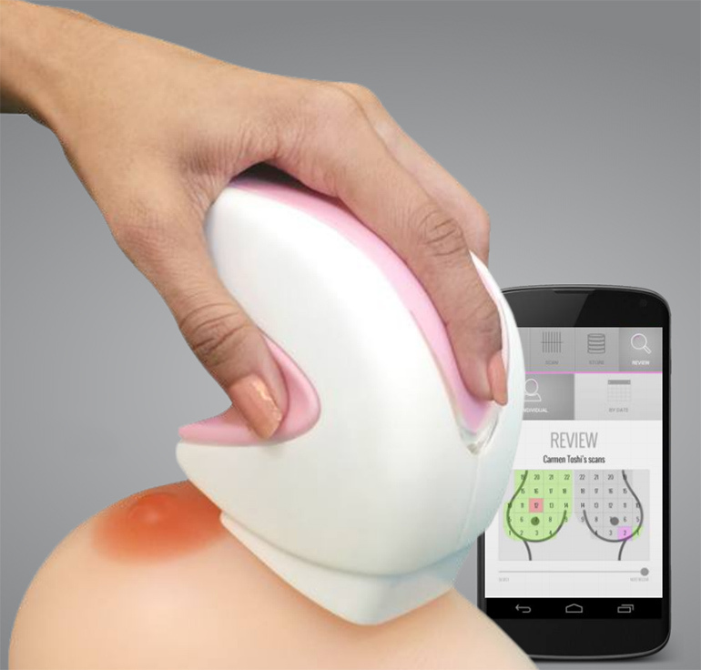
‘ibreast’ Digital
Device

Portable, radiation-free device checks for breast cancer. Women in rural areas in low-& middle income, have less access to breast cancer screening and treatment. In Barnala, they examined 100 patients and they discovered 6 at risk; in Patiala they examined 20 patients and they found 1 at risk. ALL of them referred for further treatment. Dr. Saroj Mahalaha-Ob/Gyn supervised the technicians.
“In 2008, 58% of breast cancer deaths occurred in less developed countries” WHO.
A trained technician can operate the device very easily and results are available in less than 15 mts.

