mukulparikh@gmail.com
Ummed School, Ludhiana, P.
(A school for children in slum)
Dr. Param Saini
Rotary Club Ludhiana Greater has been focusing on improving the learning outcomes of poor and underprivileged children in the slums. Their parents are daily wagers not interested in sending their children to school. The setting up the school with volunteer and convincing parents to send their children was a task in itself. Parents were reluctant to send their children to school; most kids were taking care of their younger children at home. The club began with a reward system to attract kids and slowly increased the number from 5 to 35, hired a teacher and introduced the same curriculum as offered in Govt. Schools.
Club is not only emphasizing children’s academic proficiency but also overall holistic development. On Saturdays these children are involved in number of cultural activities: dancing, singing, sports, art and craft to polish their talent in the best possible way.
These children are provided uniforms, foot wears, stationary and toiletries on regular basis. The aim is to bring about change in all aspects that affect their growth, wellbeing and potential, particularly their sanitation, health, nutrition and access to higher education. The club is proud to have sent 10 children for further education to local Govt. School in the last two years.

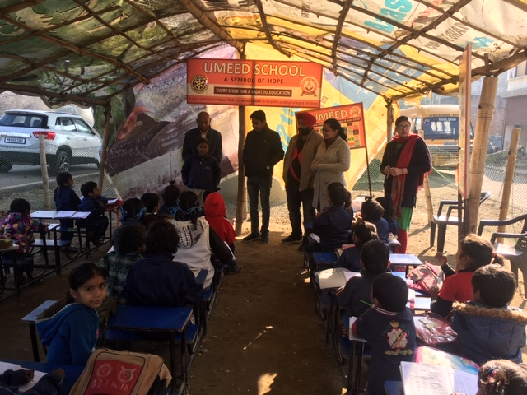
L-1

