MAHA YATRA
2019

-GANDEVI, Guj. Jan. 11-18

-BENAGALURU, K. Jan. 19-25

-LUDHIANA, Punjab Jan. 26-29

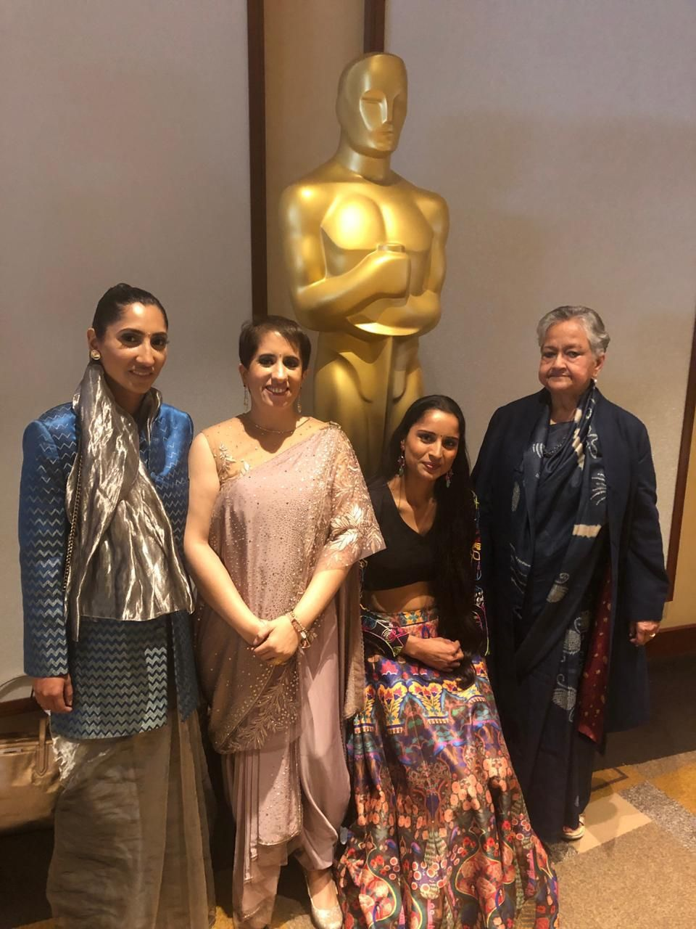

Oscar Trophy for “Period. End of Sentence” Documentary
(Sanitary Pads Revolution)
We are humbled to be Part of it. Medical YATRA started making Sanitary Pads in Kharel, Guj. in 2016; since then we have installed @ Five-5-locations in India…in 2018, we installed in Ludhiana, P.
That has helped so many hundreds of girls/women to prevent infection & have better personal hygiene boosting their self -esteem.

