**With Sanitary Pads M/C workers**

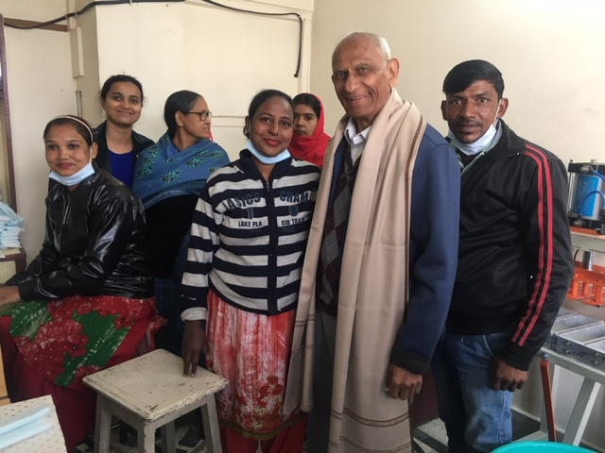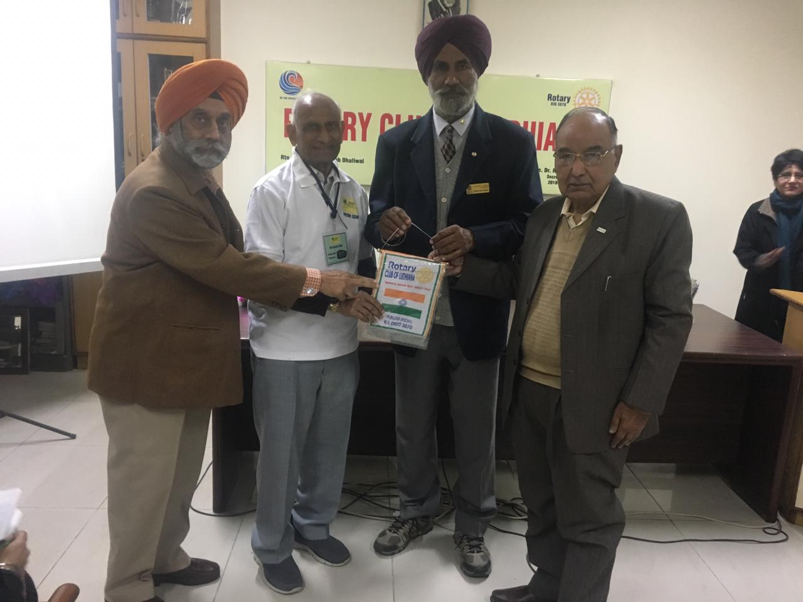

**Ludhiana, Punjab** (Jan 26-29)

* **Ummed School**
* **Rotary Reception**
* **Visit to Sanitary Pads M/C**