W.A.S.H. Initiatives (W.H.O.) by Medical YATRA-AIPNO

by Wendy Chan, Intern from Australia
& Ramesh Shah
To further broaden the volunteer experience of the Medical Yatra they organized a 2 day Community Engagement and Education program. We were welcomed and thanked by the local schools and ‘Harijan’ Community of Sonavadi with song and dance. We had a tour of the Gram Seva Trust Hospital, & we participated in “Swachh Bharat” abhiyan which is an initiative by Prime Minister Modi to clean up local community and reduce littering. We also visited local communities touring their water filtration facility, local dairy milk collection facility/co-op and also visited the installed toilets which were made possible through Rotary Clubs of Cleveland & Chagrin Highlands teaming up with AIPNO.
Sonavadi (population 2,000) has been adopted as an ‘Ideal Gram’ by Rotary Club of Gandevi, Guj. because of NO defecation, NO garbage dumps, Clean streets, CLOSED gutters and great community support system.

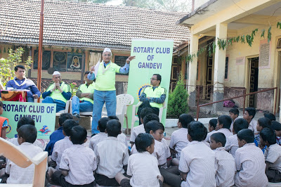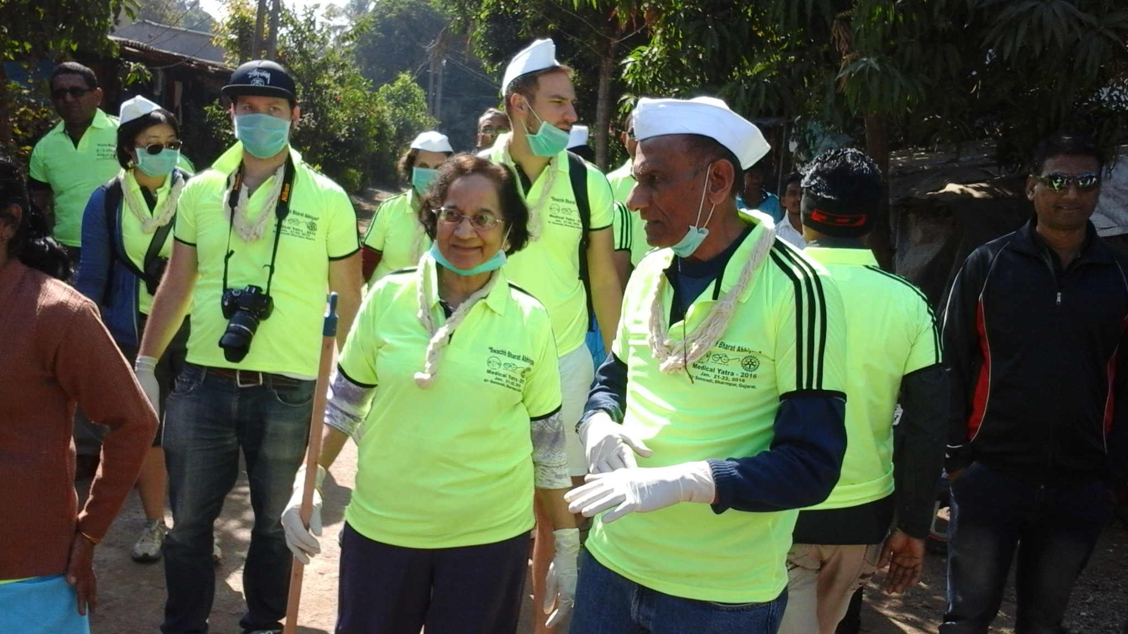
The Gram Seva Trust was established by husband and wife team Dr. Harsha and Ashwin Shah in 1994 starting as a 30 bed hospital with 5 staff has now grown to 80 bed facility with 100 staff and includes running of many community project which aims to assist women, children and the elderly including the establishment of libraries, boarding facilities for children, mobile clinics, and education on health, nutrition and hygiene. More on Gram Seva Trust can be found: http://www.gramseva.org/
In line with prior years, Aarogya Seva was again part of 2016 Medical Yatra organized in association with AIPNO, Rotary Clubs of Northern Ohio, Rotary Club of Gandevi and Gram Seva Trust.

Toilets as a human decency & disease prevention initiative
Those of us from more developed countries take for granted our access to toilets. We were initially a little puzzled by our tour of several villages just to see the constructed toilets however this is actually a very important initiative for the villages as we were told stories of women being raped when they ventured out for the bathroom alone. Prior to the construction of toilets, the women would meet up as a group to go to a secluded spot in the field to do their business. That defecation causes diarrhea, cholera, malaria and host of other diseases.

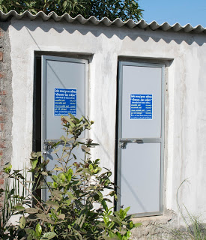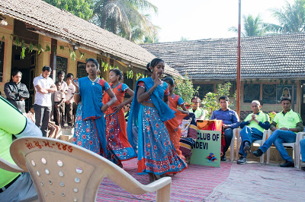

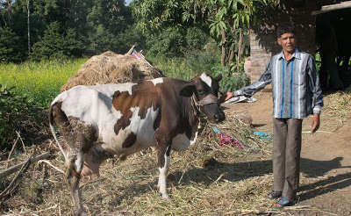 | Heifers as a Micro Enterprise  The local dairy facility we visited has become its’ own social enterprise and is a co-op for the local community. The sale of the milk has made it possible for the community to save and fund additional local initiatives such as heifer micro-lending program. The heifers are purchased via a loan and once the cow produces milk and thus an income the loan is repaid. The villager is then able to have a continuous sustainable income going forward for their families. Because of it’s success, this co-op will be used as model for nearby villages.

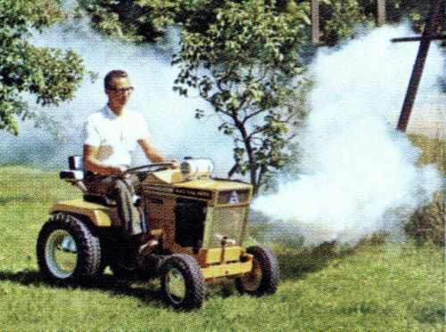 | Fogger attachment  To prevent infections from mosquito and other insects, AIPNO Medical YATRA donated Fogger attachment to tractor as requested by Sonavadi community. This attachment will serve 6 local villages and hopefully reduce malaria related deaths

Bhanuben & Vanitaben proudly shows Pads they made;  Now they want to have their own machines. | Sanitary Pads Machines  By far my favorite community initiative was the sanitary napkins women empowerment project. This is run by the women for the women and provides improved health and education as well reducing the stigma around menstruation. The sanitary napkins are made by hand from cotton and wood pulp which importantly are also biodegradable. These are then sold by women to women in their local villages at much lower cost to that which are mass produced and made from plastic and other non-biodegradable materials. This facility was based within the Gram Seva Trust Hospital and with this success they are looking to expand and replicate this to up to 15 facilities.

.
UNICEF Water, Sanitation, Hygiene (WASH) Initiative
According to the latest estimates of the WHO/UNICEF Joint Monitoring Program. for Water Supply and Sanitation (JMP), 32 per cent of the world’s population – 2.4 billion people – lacked improved sanitation facilities, and 663 million people still used unimproved drinking water sources in 2015 Inadequate access to safe water and sanitation services, coupled with poor hygiene practices, kills and sickens thousands of children every day, and leads to impoverishment and diminished opportunities for thousands more. Poor sanitation, water and hygiene have many other serious repercussions. Children – and particularly girls – are denied their right to education because their schools lack private and decent sanitation facilities. Women are forced to spend large parts of their day fetching water. Poor farmers and wage earners are less productive due to illness, health systems are overwhelmed and national economies suffer. Without WASH (water, sanitation and hygiene), sustainable development is impossible.

