AIPNO-Medical YATRA Giant Efforts
To Fight COVID-19 in India
Dr.Jaya Shah
Mr.Ramesh Shah
Dr Gita Gidwani
Dr Saroj Mahalaha
Dr Murthy Vuppala
Dr Mona Gupta
Year 2021 is credited for awesome efforts to fight infections and casualties from corona virus all around the world, -India is NOT an exception. So far government has reported 33.5 million cases, 445,000 deaths. Medical YATRA has supported a lot of projects through various NGOs to alleviate suffering and improve health of rural, tribal folks.
Oxygen Plant Surat, Guj.

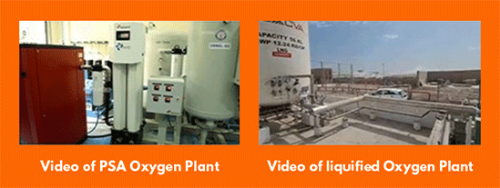
With $5,000 MY investment, supported by other partners, an Oxygen Plant costing $30,000. was installed in Surat Hospital. This will provide badly needed Oxygen to corona virus patients.

Nutrious Meals Vishakhapatnam, AP

Schools are re-opened and children are going back to schools after the pandemic. Medical YATRA with The Akshaya Patra Foundation is providing meals to hundreds of school children.

PPE Distribution, Vizag, AP
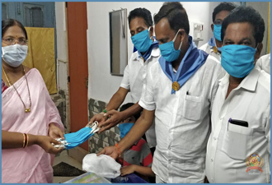 | Prasanthi Trust who help the needy. is run by 100% volunteer doctors, nurses, students of all kind with rich and poor background wholeheartedly. Money contributed has been used to distribute PPE for the covid crisis in an extraordinary way through dedicated volunteers in all villages.
.
Rehab Center Bardoli,Guj.

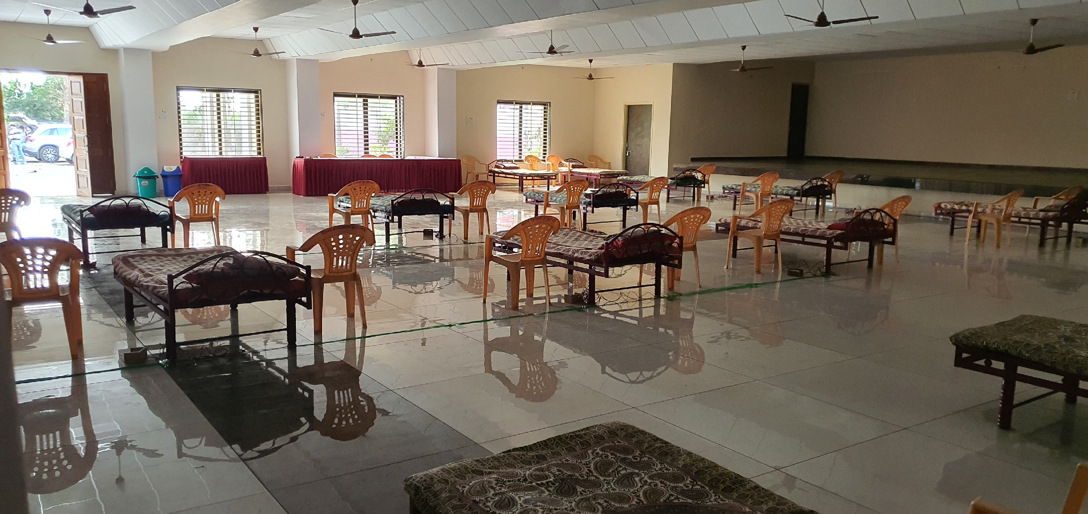
India’s efforts to vaccinate 1 billion-, a lot of them are villagers in a smaller community have got WHO attention & recognition. India’s recovery rate is 98.5% highest in the world. However, NEED for more rehab facility for patients to recover is growing.

Repurposing the Mobile Van Bengaluru, K.

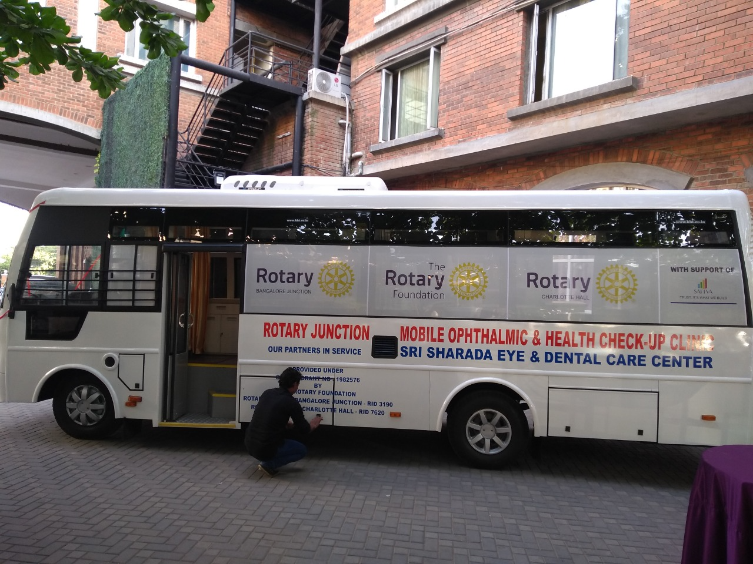
Aarogya SEVA needed a facility to examine Corona virus patients and provide rehab in the villages. Medical YATRA van was loaned to Dr. Dayaprasad to accomplish that task.

Pulse Oximeters,Bhopal,MP

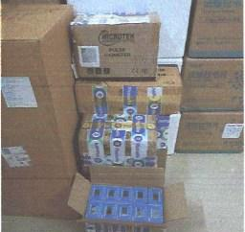 | A frontline medical worker directly monitors the health of a COVID-19 patient using the pulse oximeter.  Each oximeter impacts the lives of innumerable patients and enables them to receive timely life saving care.  The no. of the pulse oximeters delivered to Bhopal, Madhya Pradesh was 330 .

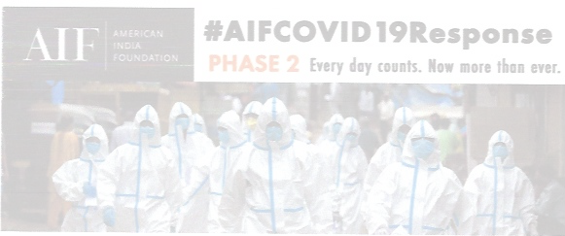
SUMMARY:

Though Medical YATRA physicians have to observe travel restrictions to India because of COVID-19, Medical YATRA is playing a very significant role because of awesome network of Rotarians created in last 20yrs. and variety of other resources developed. Medical Yatra physicians have been very creative, adaptable and always a part of solution to the health problems in front of them.

