Compassionate Caring  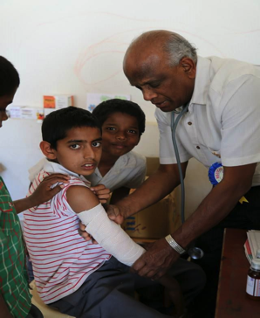  -Dr. Vuppala treating with extreme love & caring | CPR Training Saves Lives!!  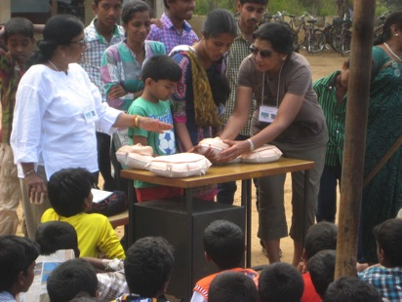  1,000 students and teachers trained  by Purnima Kotiya /Indira Mehta-N.C. | TOILETS  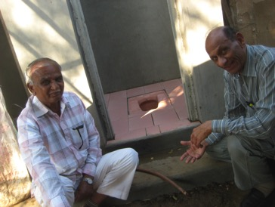  100 Toilets in Pipalaghar, Guj. To be constructed by YATRA-AIPNO.  -Improved Personal Hygiene  -Prevent water & mosquito borne ailments  -Eliminates foul smell & open defecation -Ecofriendly | Laughing YOGA  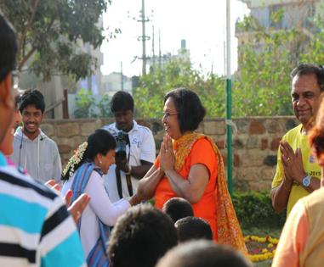  Jayanthiji Ramanan& Purnima Kotiya  From N.C. conducted Laughing YOGA exercises to a group of 100+ on a Republic Day.
Republic Day Ceremony  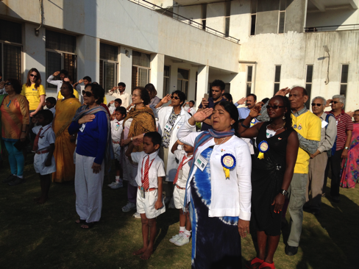  With Narendra Nelle orphanage students, Flag Hosting ceremony on Jan.26. | Physical Therapy  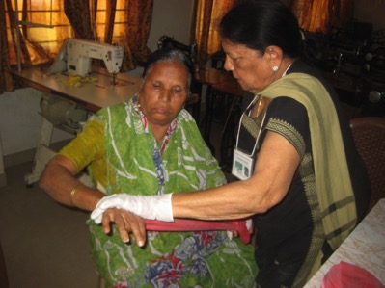  -200 patients trained in ‘pain management’-by N.Bavishi ;  She also gave out FREE “Theraband”  To patients. | Gift of Sight  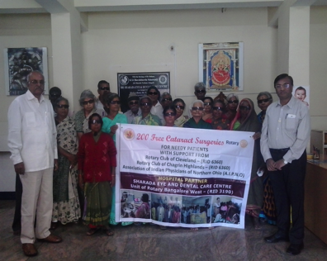  200 Cataract Surgeries funded by  YATRA donors In Bangalore  thru Rotary of Bangalore | Physician & Pharmacist !!  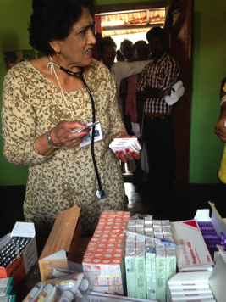  “Whatever it takes to make my patient Happy, I am willing to do”  S.Kampani  Almost ALL medicines were DONATED by pharmacy companies.

