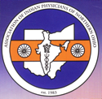 | Medical YATRA-2015  @ Mysore / Bangalore, K. Jan. 18-28  Hosted by SEWA Int’l and its affiliates  Jaya Shah, Gita Gidwani & Ramesh Shah

“Clean India”  (“Swachh Bharat” Abhiyan)  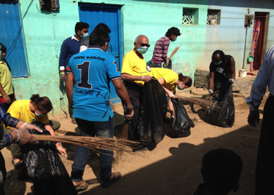  -YATRIs participated in ‘Swachh Bharat’ abhiyan’ in 2 streets clean up in Bangalore slums.  -Prevents diseases  -Creates sense of community and Good hygiene.  -Healthy Living  -Prime Minister Modi has taken this project all over India.  -Celebrities-Amitabh Bachachan, Salma Khan and others have joined this campaign.  Also, we found more clean rest rooms in Gujarat and Karnataka than ever before. Indian travellers are demanding more cleanliness in public facilities.  Visit website: swachhbharat | 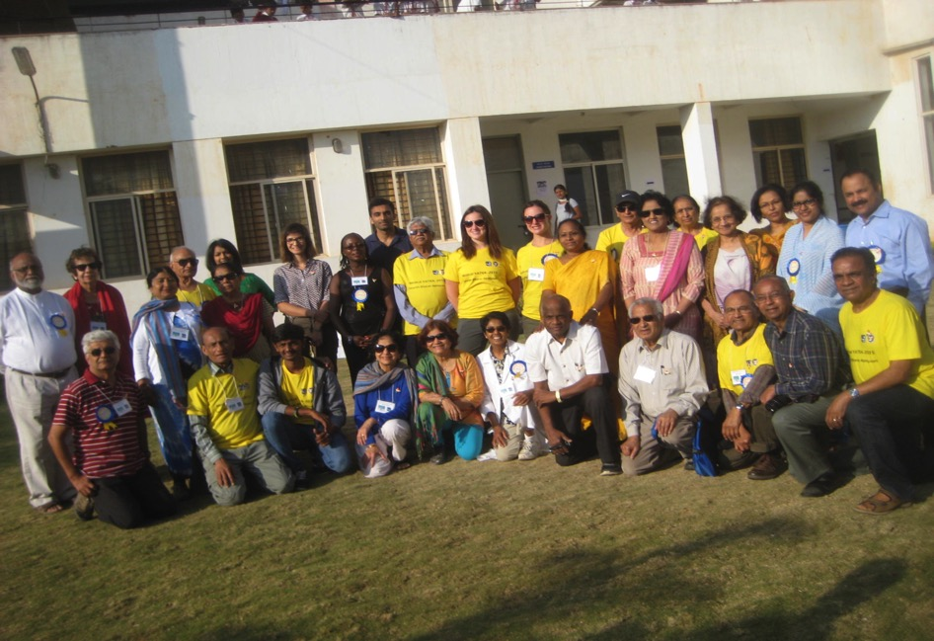  - 17 Physicians and 20 Volunteers = TEAM of 37 worked 6 days in Mysore villages & 4 days in  “Coming Together is a Beginning; Keeping Together is a Progress; Working Together is Success.”  Bangalore slums helping 8,000+ patients with diagnostic primary care and FREE medicines.  - Clev. YATRIs- Dr.M.Vuppala, Dr.G.Goud, Dr.G.Gidwani,Dr.S.Mahalaha,Dr.S.Kampani, Dr.V.Patel,  Dr.A. Argekar, Dr.B. Roy, Dr. J. Shah, Dr .E.Prot, Dr.R.Bhimani, Dr.K.Moses; Dr.S.Meyyazhagan  J.Ramanan, R.Ramanan, S.Kampani, J.Vuppala, B.Bavishi, N.Bavishi,E.Conroy,J.Patel, M.Patel,  P. Argekar, V.Goud, R.Shah  Association of Indian Physicians of Northern Ohio (AIPNO) founded in 1983 is a non-profit membership organization of physicians of Indian origin in N.Ohio. AIPNO provides the opportunity to make meaningful contribution to the local community. Thru “Chiraag” annual fund raising, event, AIPNO have supported more than 30 local charities, one every year. Thru Medical YATRA programs, AIPNO also provides service to aid to underserved areas and disaster affected sites in India and around the world. AIPNO physicians have traveled to Mexico, Haiti, Peru, Burundi, Ecuador, Uganda, Kenya, Honduras, Dominican Republic, Guyana and India. In India, YATRA medical Mission program have been conducted in Kerala, Tamilnadu, Rajasthan, Orissa, Gujarat, Uttarkhand, Maharashtra , Karnataka and W. Bengal. AIPNO has served more than 160,000 patients and more than 100 physicians from USA, Canada, UK and India have participated. Visit our website: aipno.org and medicalyatra.org & clevelandpeople.com | Sanitary Napkins Project  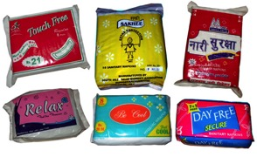  For Women, By Women  Medical YATRA donors have  donated the machine invented by  Muruganatham from Coimbatore  to start a Microenterprise by  women from Gram Seva Trust,  Kharel, Guj.  Machine will make 1500Napkins per day.  This project will accomplish:  -Hygienic way of living,  -Improved Health;  -Prevents Infections,  -Generates Income  -Increases Self esteem  -NO missing school days  -ECO friendly  AIPNO goal is to have multiple  multii independent “Gram Udyog” to serve serve the needs of local girls and and women inexpensively.

